Gathering Zion 2009

Hygiene Kit Service Project

One hygiene kit includes the following items:
2 unbreakable combs without sharp handles
4 toothbrushes in sealed packages
1 tube of toothpaste, 6-8 ounces, no pumps
2 bars of soap, 3.5 to 5 ounces each
2 hand towels approximately 15 x 25 inches
(No dishtowels or washcloths. If sewing towels,
Serge or zig-zag the edges to prevent fraying.)
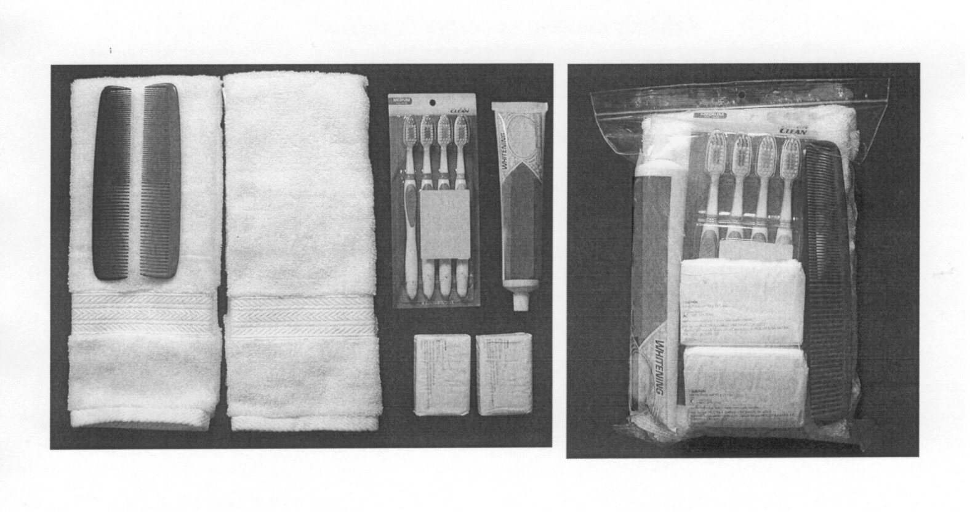
As part of our trek preparations, we will remember the legacy of the pioneers and strive to make life a little easier for others.

From February 1 to May 1, all youth ages 12 to 18 in the East Mill Creek Stake are invited to gather supplies needed to make hygiene kits to be given to the LDS Church Humanitarian Center. The kits will be assembled by the youth at the May 16th Aaronic Priesthood Commemoration Event. The stake will provide the bags for the kits.

As with all Humanitarian Center donations, quality is more important than quantity. Please follow the guidelines closely and donate only the items requested.

Hygiene kits are sent to orphanages, homeless shelters, medical facilities and disaster areas.

