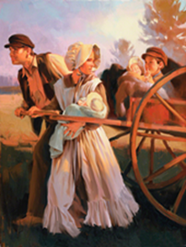 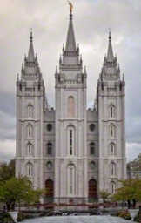

Press Forward Steadfast In Faith

**Trek June 26-29, 2013**    
2 Nephi 31: 20 East Mill Creek Stake

**2013 Trek Theme**

**Definitions:** **Press:** steady pushing. **Steadfast**: firmly loyal, constant, unchanging, firm in belief. Faith: A vigorous belief in Heavenly Father and Jesus Christ. Hearken: Hear and act.

**Theme emphasis:** Faith in Jesus Christ. Family. Be temple worthy. Serve in the Temple. The Plan of Salvation. We can do difficult things. Trek step by step. Faith in every footstep. Pioneer heritage. A perfect brightness of hope. Love of God and all mankind. Fun. Adventure.

**2 Nephi 31:20** Wherefore, ye must press forward with a steadfastness in Christ having a perfect brightness of hope and a love of God and of all men, feasting upon the word of Christ, and endure to the end, behold, thus saith the Father: Ye shall have eternal life.

**Hymn 81:**

**1. Press forward, Saints, with steadfast faith in Christ**,  
With hope’s bright flame alight in heart and mind,  
With love of God and love of all mankind. Chorus: Al-le-lu-ia !

2. Press forward, feasting on the word of Christ.  
Receive his name, rejoicing in his might.  
Come unto God; find everlasting light.

3. Press on, enduring in the ways of Christ.  
His love proclaim thru days of mortal strife.  
Thus saith our God: “Ye have eternal life!”

**“Stand Ye in Holy Places” (**[**D&C 87:8**](https://www.lds.org/scriptures/dc-testament/dc/87.8?lang=eng#7)**). 2013 YW/YM Theme**

**2 Nephi 12:3** …let us go up to the mountain of the Lord, to the house of the God of Jacob, and he will teach us of his ways, and we will walk in his paths…

**Helaman 3:28-30** Yea, thus we see that the gate of heaven is open unto all, even to those who will believe on the name of Jesus Christ, who is the son of God.